**EXPNO 12:CREATE A CLONING OF A VM AND TEST IT BY LOADING THE PREVIOUS VERSION/CLONED VM.**

**DATE:29.09.2025**

**AIM:**

To create a cloning of a vm and test it by loading the previous version/cloned vm.

**PROCEDURE:**

STEP 1: GO TO VM AND GOTO MANAGE AND CLICK CLONE

STEP 2: CLICK CLONE

STEP 3: SELECT THE FULL CLONE

STEP 4: AFTER CLONE AGAIN OR VM IS OPENED.

**IMPLEMENTATION:**

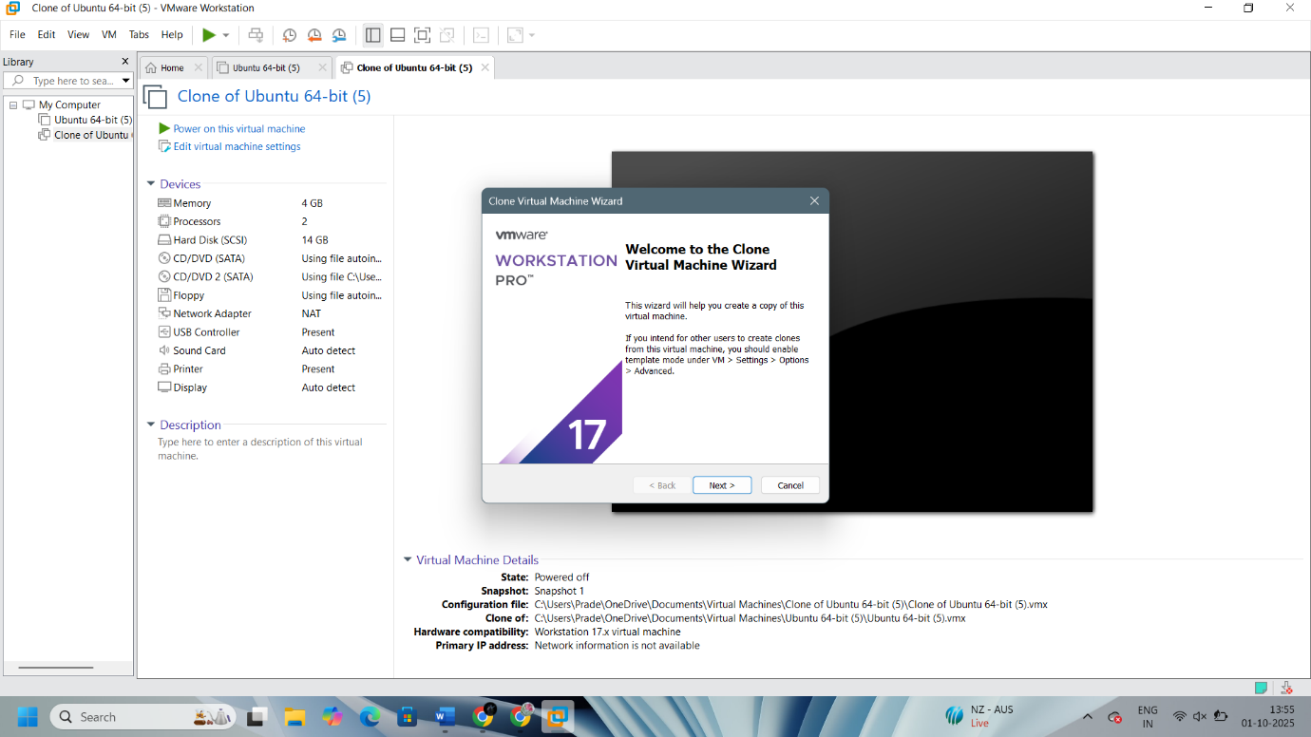

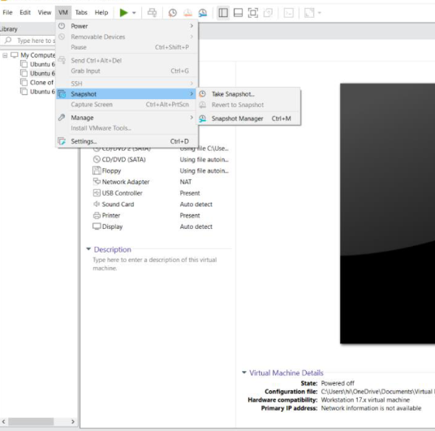

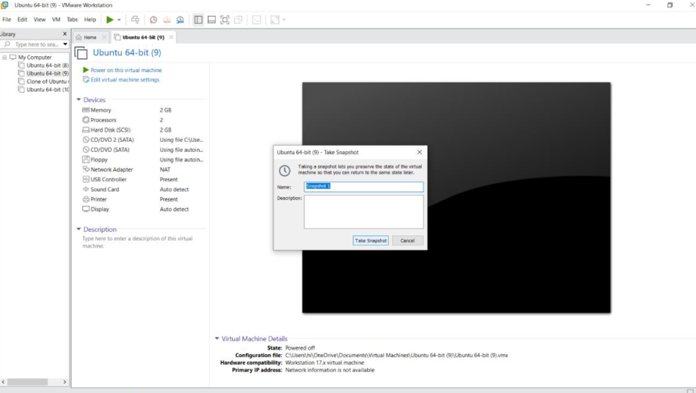

**Result:**

A cloning of a vm and test it by loading the previous version/cloned vm has been created.